//odd

class Odd
{
public static void main(String args[])
{
int i=10;

if(i%2==0)
{

System.out.println("num is even");
}
else
{
System.out.println("num is odd");

}
}

}


//greatest num
class Great
{
public static void main(String args[])
{
int a=10;
int b=12;
int c=14;

if((a>b)&&(a>c))
{

System.out.println("a is greater");
}
else if(b>c)
{

System.out.println("b isgreater");
}
else
{
System.out.println(" c is greater");

}
}

}

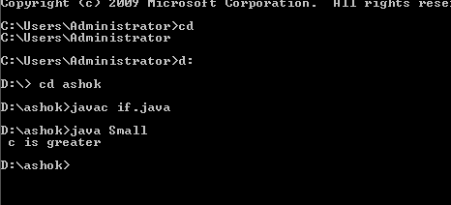

//smallest num
class Small
{
public static void main(String args[])
{
int a=10;
int b=12;
int c=14;

if((a<b)&&(a<c))
{

System.out.println("a is smaller");
}
else if(b<c)
{

System.out.println("b is smaller");
}
else
{
System.out.println(" c is smaller");

}
}

}

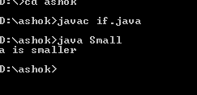
//leap year
class Leap
{
public static void main(String args[])
{
int a=2012;

if(a%4==0)
{

System.out.println("year is leap");
}
else
{

System.out.println("year is not leap");

}
}

}

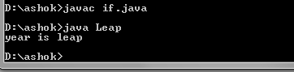
//grade

class Grade
{
public static void main(String args[])
{
int a=80;

if(a>=90)
{

System.out.println("s grade");
}
else if((a<89)&&(a>=80))
{

System.out.println("A grade");
}
else if((a<79)&&(a>=70))
{

System.out.println("B grade");
}
else if((a<69)&&(a>=60))
{

System.out.println("C grade");
}

else if((a<59)&&(a>=50))
{
System.out.println("D grade");

}

else
{

System.out.println("RA");
}
}

}

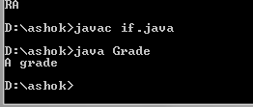

Switch print num
class Grade
{
public static void main(String args[])
{
int a=10;

switch(a)
{
case 1:
System.out.println("one");
break;
case 2:
System.out.println("two");
break;
case 3:
System.out.println("three");
break;
case 4:
System.out.println("four");
break;
case 5:
System.out.println("five");
break;
case 6:
System.out.println("six");
break;
case 7:
System.out.println("seven");
break;
case 8:
System.out.println("eight");
break;
case 9:
System.out.println("nine");
break;
case 10:
System.out.println("ten");
break;
}
}
}

